Student worksheet answers

4.1 Synthesis and decomposition reactions can be represented by equations

Pages 90–91

Synthesis and decomposition reactions

1 Why does classifying compounds into groups make them easier to name and identify?

Classifying reactions into different types helps us predict the products produced by reactions and understand what reactants are required to produce particular products.

2 What is the law of conservation of mass?

Mass/matter cannot be created or destroyed. It is the reason why chemical equations must be balanced.

3 With regard to chemical reactions, explain the following.

a Synthesis reaction

The building up of compounds by combining simpler substances, normally elements

b Decomposition reaction

The breakdown of compounds into simpler substances, either elements or more simple compounds

c Electrolytic decomposition

The breakdown of compounds into simpler substances using electricity

d Thermal decomposition

The breakdown of compounds into simpler substances using heat

e Hydrolysis reaction

A reaction with water

4 Predict the products of the following chemical reactions, balance the chemical equation, and identify the reaction as synthesis or decomposition.

a 2Na(s) + Cl2(g) → 2NaCl(l) synthesis

b 2H2O(l) → 2H2 (g) + O2(g) decomposition (electrolytic)

c 2Mg(s) + O2(g) → 2MgO (s) synthesis

d 2HCl(aq) + Mg(s) → MgCl2(aq) + H2(g) decomposition and synthesis

e N2(g) + 3H2(g) → 2NH3 (g) synthesis

f 4Na(s) + O2(g) → 2Na2O(s) synthesis

g CuSO4.5H2O(s) → CuSO4(s) + 5H2O(g) decomposition

Extend your understanding

Conduct some research on the process of electroplating and answer the following questions (also using your knowledge of electrolysis).

5 How is electroplating used in production and manufacturing?

To coat metal products in a different metal that is less reactive

6 Explain how electroplating is used in the following industries.

a Food industry

Tin cans are cans made from steel (or a similarly cheap metal) and are electroplated (coated) in tin.

b Car-manufacturing industry

Cars are manufactured from iron or steel, and then pieces of the car are electroplated in a less reactive metal (sometimes paint is the protective coating).

c Jewellery-making industry

Often jewellery is made from cheap metals, such as copper, and then electroplated in gold, silver or platinum.

7 What would happen to some metals if they did not undergo electroplating?

Corrosion

8 Is electroplating necessary for all metals? Explain your answer.

Not all metals are susceptible to corrosion. As such, only metals that are highly reactive (i.e. undergo hydrolysis – a reaction with water) will corrode, causing rust.

Student worksheet answers

4.2 Acid reactions depend on strength and concentration

Pages 92–93

Acid reactions

1 What is an acid?

Acids are molecular compounds that form ions when they donate a H+ ion.

2 What are the properties of acids?

Acids taste sour, turn litmus paper red and have a pH of less than 7. Strong acids are corrosive; weak acids are found in foods.

3 What do all acids have in common?

All acids contain a hydrogen ion (H+), which they donate when they dissociate in water.

4 What is a base?

Bases are molecular compounds that form ions when they gain a H+ ion.

5 What are the properties of bases?

Bases have a bitter taste, turn litmus paper blue, feel slippery and have a pH of greater than 7.

6 What do all bases have in common?

All bases contain a hydroxide ion (OH–), which will gain a hydrogen ion when they dissociate, forming water.

7 What are the products of any acid–base reaction?

Salt and water

8 What is this type of reaction called?

Neutralisation

9 Why is it called this?

The products have a pH of 7 (neutral), as opposed to an acidic or basic pH.

10 What are the products of the following metal reactions?

a acid + base

salt + water

b acid + metal

metal salt + hydrogen

c acid + metal oxide

metal salt + water

d acid + metal carbonate

metal salt + water + carbon dioxide

11 Write balanced chemical equations, including states, for the following reactions.

a H2SO4(aq) + 2NaOH(aq) → Na2SO4(aq) + 2H2O(l)

b 2HNO3(aq) + 2Na(s) → 2NaNO3(aq) + H2(g)

c 2HCl(aq) + MgO(s) → MgCl2(aq) + H2O(l)

d 2HF(aq) + Na2CO3(s) → 2NaF(aq) + CO2(g) + H2O(l)

12 Identify the following images as either a dilute strong acid, a concentrated strong acid, a dilute weak acid, or a concentrated weak acid.

|  |  |  |  |
| --- | --- | --- | --- |
|  |  |  |  |
| Concentrated weak acid | Dilute strong acid | Concentrated strong acid | Dilute weak acid |

Extend your understanding

13 Research acids and bases that are located within your body and answer the following questions.

a What is the main acid found within your stomach?

Hydrochloric acid

b Is this a strong or weak acid?

Strong acid

c What happens to this acid when it leaves the stomach and enters the small intestine?

It is neutralised in the small intestine by bile from the pancreas

d Why does the acid have to be treated before it enters the small intestine?

Otherwise the corrosive strong acid would burn the small intestine

e What happens if your body produces excessive acid within your stomach?

The stomach develops an ulcer (a painful sore in the stomach lining) as the acid burns it

Student worksheet answers

4.3 The solubility rules predict the formation of precipitates

Pages 94–95

Precipitation reactions

1 What do the following terms mean?

a Soluble

A chemical that will dissolve in water to become aqueous (aq)

b Insoluble

A chemical that does not dissolve in water, and is a solid

c Precipitate

A solid product that is formed in a chemical reaction

d Spectator ion

An ion that does not participate in a chemical reaction

2 For each of the following molecules, determine whether it is soluble or insoluble, and assign a state to each.

a AgNO3

soluble (aq)

b NH4Cl

soluble (aq)

c PbCl2

insoluble (s)

d Cu(OH)2

insoluble (s)

e Fe(OH)3

insoluble (s)

f NaNO3

soluble (aq)

g AgCl

insoluble (s)

h Na2CO3

soluble (aq)

i Na3PO4

soluble (aq)

j (NH4)2CO3

soluble (aq)

3 Write a balanced chemical equation for the following precipitation reactions, including states.

a Pb2NO3 + NaCl →

Pb2NO3 + NaCl → Pb2Cl(s) + NaNO3(aq)

b Na2CO3 + MgCl2 →

Na2CO3 + MgCl2 → MgCO3(s) + 2NaCl(aq)

c NaOH + MgBr2 →

2NaOH + MgBr2 → Mg(OH)2(s) + 2NaBr(aq)

4 Write a balanced chemical equation for the following precipitation reactions, including states.

a silver nitrate and barium chloride

2AgNO3(aq) + BaCl2(aq) → 2AgCl (s) + Ba(NO3)2

b sodium bromide and lead (II) nitrate

2NaBr(aq) + Pb(NO3)2(aq) → 2NaNO3(aq) + PbBr2(s)

c mercury (II) nitrate and sodium iodide

Hg(NO3)2(aq) + 2NaI(aq) → HgI2(s) + 2NaNO3(aq)

d sodium phosphate and calcium chloride

2Na3PO4(aq) + 3CaCl2(aq) → 6NaCl(aq) + Ca3(PO4)2(s)

e magnesium sulfide and copper (II) nitrate

MgS(aq) + Cu(NO3)2(aq) → Mg(NO3)2(aq) + CuS(s)

f lithium sulfate and barium chloride

Li2SO4(aq) + BaCl2(aq) → 2LiCl(aq) + BaSO4(s)

Extend your understanding

5 A chemist wishes to determine the amount of salt (NaCl) in a packet of chicken soup. She starts by dissolving the soup in hot water, allowing it to cool and then filtering the solid particles out of the solution.

a Suggest a method the chemist could incorporate that would allow her to determine how much salt is in the soup. You must outline the chemicals you would use and the procedure you would follow.

Answers will vary but should follow the following format:

• React the soup with silver nitrate to precipitate the salt as silver chloride.

• Measure the mass of the silver chloride (if students understand the mole concept it could be discussed here).

• Filter the precipitate and dry it to a constant mass.

• Calculate the mass of the precipitate and thus the NaCl.

b Identify two errors that may be involved with this experiment. They could be in the method you have outlined above or in the initial procedure that the chemist used. What would you do to minimise their effect on your results?

Answers may vary, but must relate to the method and its specific effect on results.

• There is an assumption that only the NaCl will react with the AgNO3. Determine whether lead or mercury are in the soup (hopefully not!) to avoid these precipitates.

• Weigh the precipitate to a constant mass. This ensures there is no water in the final mass, which would increase the mass of the precipitate and overestimate the mass of NaCl in the soup.

• React the soup with an excess amount of AgNO3 to ensure all the NaCl reacts.

Student worksheet answers

4.4 Combustion reactions between hydrocarbons and oxygen produce carbon dioxide, water and energy

Pages 96–97

Combustion reactions

1 Explain the following terms.

a Oxidation

A reaction with oxygen

b Combustion

A reaction with oxygen to produce carbon dioxide, water and energy

c Limited oxygen

Occurs when there is not enough oxygen to fully react with the other reactant

d Carbon economy

The economy of a society that is based on carbon as a main fuel source

2 Provide an example for the following reactions (different from the examples in your student book).

a Oxidation reaction with metals

Answers will vary. For example, 4Na(s) + O2(g) → 2Na2O(s)

b Oxidation reaction with non-metals

Answers will vary. For example, S(g) + O2(g) → SO2(g)

3 Write a balanced chemical equation for the combustion of the following hydrocarbons.

a Methane

CH4 + 2O2 → CO2 + 2H2O

b Ethane

2C2H6 + 7O2 → 4CO2 + 6H2O

c Propane

C3H8 + 5O2 → 3CO2 + 4H2O

d Butane

2C4H10 + 13O2 → 8CO2 + 10H2O

e Pentane

C5H12 + 8O2 → 5CO2 + 6H2O

f Hexane

2C6H14 + 19O2 → 12CO2 + 14H2O

g Heptane

C7H16 + 11O2 → 7CO2 + 8H2O

h Octane

2C8H18 + 25O2 → 16CO2 + 18H2O

4 How has the burning of fuels changed over time? Explain with reference to the different fuels that have been used.

Our ancestors burnt wood, which is mainly the carbon compound cellulose. Later generations burnt coal, which is close to pure carbon. Coal is made by the dehydration and compaction of buried plant remains. Our generation uses coal to produce electricity and petroleum as a liquid fuel for transport.

5 Fuels that are derived from plants are said to be ‘carbon neutral’. What does this term mean?

Plants remove carbon dioxide from the atmosphere by photosynthesis and store it. Plant matter is burnt, releasing the carbon back into the atmosphere with no net effect on the amount of CO2 in the atmosphere.

Extend your understanding

6 Research fractional distillation. Use your knowledge and Figure 4.7 on page 97 of your student book to answer the following questions.

a What is fractional distillation?

Distillation is a separation technique where a mixture of liquids can be separated into pure liquids. In fractional distillation, the mixture is separated into several different parts called fractions.

b What is crude oil made from and why is it called ‘crude’ oil?

Crude oil is a mixture of hydrocarbons. It is called crude as it is in its natural state – straight out of the ground and not yet processed or refined.

c In Figure 4.7 of your student book, what do you notice about the trend between temperature and the number of carbon atoms?

A smaller number of carbon atoms requires a lower temperature to purify the hydrocarbon

d What can you conclude about the boiling points of hydrocarbons?

The more carbons that the hydrocarbon contains, the higher the boiling temperature

e What happens to the residue?

It is used as bitumen for roads and roofs

Student worksheet answers

4.5 Polymers are long chains of monomers

Pages 98–99

Polymers and polymerisation reactions

1 Explain the following terms.

a Monomer

A small molecule from which polymers are made

b Polymer

A large molecule made of many monomers bonded together

c Covalent bond

A bond created by the sharing of electrons between two non-metals

d Linear polymer

Long-chain polymers, with minimal branching

e Cross-linked polymer

Long-chain polymers, with significant branching between chains

2 Identify the following structures as linear or cross-linked polymers.

|  |  |
| --- | --- |
|  | Cross-linked polymer |
|  | Linear polymer |
|  | Linear polymer |
|  | Linear polymer |

3 Identify the structures as thermoplastic or thermosetting polymers.

|  |  |
| --- | --- |
|  | Thermosetting polymer |
|  | Thermoplastic polymer |
|  | Thermoplastic polymer |
|  | Thermoplastic polymer |

4 Name three thermoplastic polymers and three thermosetting polymers (different from those given in your student book).

Answers will vary. Examples may include:

• Thermoplastic – zip-lock bags, nylon (clothes), styrofoam, water bottles, PVC pipes

• Thermosetting – epoxy resin, super glue, laminate, electrical fittings

5 Draw the polymers that would result from the following monomers.

|  |  |
| --- | --- |
| Monomer | Polymer |
|  |  |
|  |  |
|  |  |

Extend your understanding

Biomolecules are polymers of more simple molecules. Research biological polymers and answer the following questions.

6 What is the common name for a carbohydrate?

Sugar

7 What is the monomer of this biomolecule? Include a diagram of the monomer.

Glucose

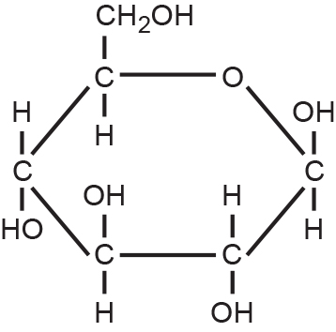

8 What is the common name for lipids?

Fats

9 What is the monomer of this biomolecule?

Triglyceride (glycerol + 3 fatty acids)

10 What is a monomer of DNA called?

Nucleotide

11 What molecules is the monomer made up of?

Nitrogenous base + sugar + phosphate

12 What monomer is a protein made of?

Amino acids

13 How does DNA turn into a protein? Very briefly explain the process.

The DNA is copied in the nucleus and this copy is called RNA. The RNA leaves the nucleus and travels to the ribosomes. At the ribosomes, the RNA is translated by binding to amino acids. The amino acids bond together to form a protein.

Student worksheet answers

4.6 Temperature, concentration, surface area and stirring affect reaction rate

Pages 100–103

Factors affecting the rate of a chemical reaction

1 Explain the collision theory.

A theory that states the particles involved in a chemical reaction must collide in order to react

2 What are the two requirements of collision theory that allow reactants to form products?

• Reactants must collide with the correct orientation.

• Reactants must collide with enough energy to break the bonds of reactants.

3 For each of the following, explain which of the situations will result in a faster rate of chemical reaction and explain why.

a A mug of hot water and a mug of cold water dissolve a teaspoon of coffee.

The mug of hot water will dissolve the coffee faster. Increased temperature means particles have more kinetic energy and move faster, and will therefore have more successful collisions.

b A whole cube of sugar and a teaspoon of granulated sugar dissolve in a cup of room-temperature water.

Granulated sugar will dissolve faster as it has a greater surface area. This means there is more reactant to collide with, and there will be more collisions.

c A 2 g tablet of calcium dissolves in 2M HCl (concentrated) and 0.01M HCl (dilute).

2M HCl will dissolve the tablet faster as it has a higher concentration. An increased number of particles means there will be more collisions between reactants.

d Two teabags are placed in two cups of hot water. One cup of tea is stirred; one is not.

The stirred tea will dissolve faster as particles have more kinetic energy. This makes particles move faster and therefore have more successful collisions.

Extend your understanding

Jack and Trinity devised different methods to dissolve a vitamin C tablet in 100 mL of water in a beaker. They both believed their method would dissolve the tablet the fastest and made a bet. To determine the winner of the bet, they decided to run the experiments to find out which method dissolved the tablet the fastest.

A control was run first – a whole tablet was dissolved in 100 mL of water at 20°C.

Jack dissolved his tablet in 100 mL of water after he had heated it to 40°C.

Trinity broke her tablet into four and then dissolved the pieces in 100 mL of water at 20°C.

4 What was Jack’s hypothesis?

Jack predicted that an increase in temperature would result in a faster rate of reaction, as particles would have increased kinetic energy, move faster and collide more frequently.

5 What is Trinity’s hypothesis?

Trinity predicted that an increased surface area would result in a faster rate of reaction, as there would be more reactant to collide with, therefore increasing the number of successful collisions.

6 Why was a control used? What was its purpose?

The control was used as a comparison. A control is designed to be conducted if the variables had not been changed. Thus, Jack and Trinity can determine the effect of altering one variable.

7 Using your knowledge of rates of chemical reactions, which method do you think will dissolve the tablet the fastest? Explain why.

Answers will vary. Students may state that either will occur faster as long as they can justify their answer by explaining chemical rates of reaction.

8 The results gained from the experiment are shown below. Use the grid provided to graph the results.

|  |  |  |  |
| --- | --- | --- | --- |
|  | Control | Jack | Trinity |
| Size of tablet | Whole tablet | Whole tablet | Tablet in four pieces |
| Temperature (°C) | 20 | 40 | 20 |
| Time to dissolve (s) | 50 | 40 | 35 |

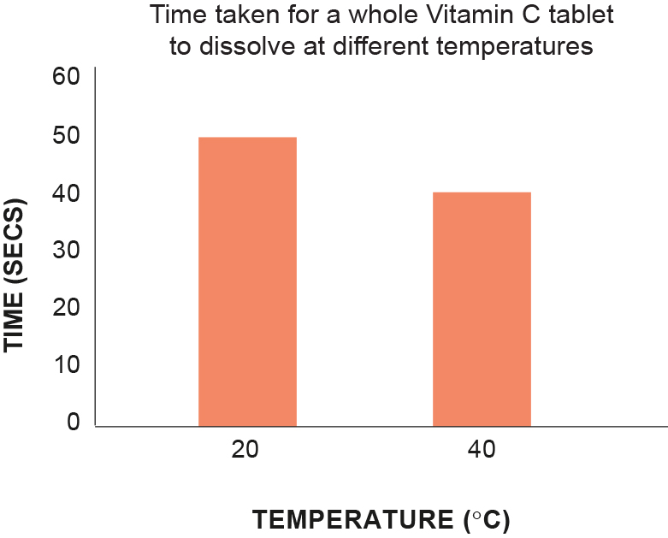 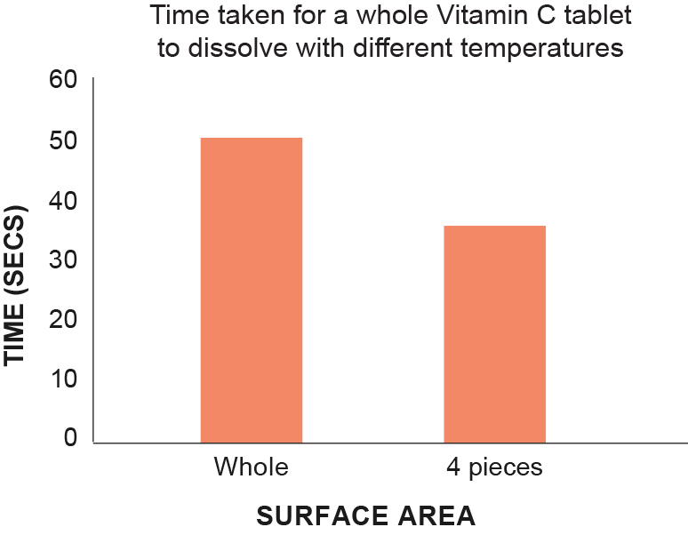

9 Are the students able to compare their results? Explain your answer.

Although it is clear that Trinity won the bet, there is no scientific way that the students can compare their results. This is because they both changed different things in their experiments and so their variables for both experiments were different. This is evident in the fact that they cannot be graphed on the same graph.

10 Suggest improvements for Trinity and Jack to dissolve their tablets faster.

Answers may vary.

• Trinity – crush the tablet, increase the temperature of the water, stir the water

• Jack – crush the tablet, increase the temperature of the water even more, stir the water

Student worksheet answers

4.7 Catalysts increase the rate of a reaction

Pages 104–105

The effect of catalysts on the rate of a chemical reaction

1 State how catalysts work.

Solid catalysts provide a surface on which the two reactants can meet in the correct orientation, allowing the products to be formed. The products are then released. Other catalysts take part in the initial reaction and are regenerated in the final reaction.

2 What is the purpose of a catalyst?

To increase the rate of a chemical reaction

3 Using your knowledge of chemical reactions, explain how a catalyst can increase the rate of a chemical reaction.

The particles of reactants get adsorbed (stuck onto) the surface of a solid catalyst where they react to form the products. The products are then released and the catalyst can be used again.

4 What agreement was made in the Montreal Protocol in 1987?

Chlorofluorocarbons (CFCs) would be phased out

5 Explain why this decision was so important for society.

CFCs that were depleting the ozone layer are no longer released into the atmosphere. Instead, ‘ozone-friendly’ chemicals are now used.

Extend your understanding

Pressure also affects the rate of a chemical reaction.

6 What types of chemical reactions would be affected by pressure?

Reactions involving gases

7 The diagram below shows gas particles in three different containers (with yellow weights holding the lids on the containers). Which of the containers has the highest concentration? Explain why.

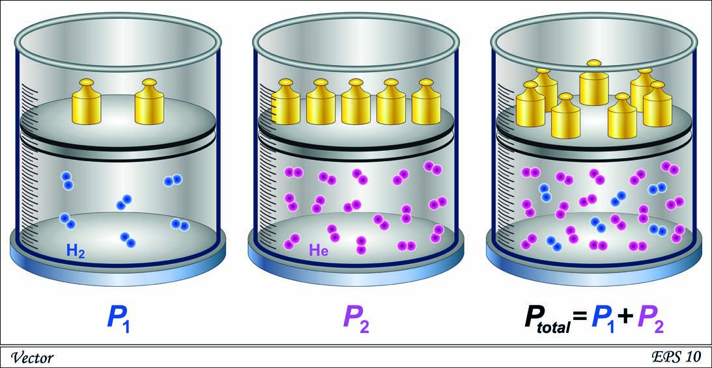

The right container, as it has the most particles in the same volume

8 Why are there more weights holding the lid on the right container?

The lid must be held down with more weight as there is more pressure and the lid may blow off

9 Which of the above containers would have a higher pressure?

The right container has the highest pressure

10 Explain the relationship between the concentration of gases and pressure.

As concentration increases in a gaseous system, the pressure will also increase

11 A half-empty bottle of water is left in the sun on a warm day. What happens to the bottle? Explain your answer.

If left in the sun, the bottle will expand. This is because the gas particles inside the bottle have been heated up, which gives more kinetic energy to the gas particles. Thus, the particles will move and increase the pressure of the bottle.

Student worksheet answers

4.8 Green chemistry reduces the impact of chemicals on the environment

Pages 106–107

Green chemistry

1 What is green chemistry?

An approach to the production of chemicals in the chemistry industry. It aims to maximise efficiency while minimising waste that may be harmful to humans and the environment.

2 In the space provided, design a poster that promotes green chemistry to the public. Ensure you include what people should and should not do (or purchase) to follow the principles of green chemistry.

Answers will vary but should focus on encouraging people to buy/use products and incorporate a lifestyle that reduces their carbon footprint and reduces their impact on the environment.

Extend your understanding

3 Research the 12 principles of green chemistry. Complete the table below by stating each principle and explaining how each can be used to reduce waste in the chemical industry.

|  |  |  |
| --- | --- | --- |
|  | Principle | How it can be used to reduce waste |
| 1 | Waste prevention | Planning chemical reactions and synthesis of products that produce minimal waste – rather than cleaning it afterward, prevent it from happening. |
| 2 | Atom economy | Maximising the number of atoms from the reactants that turn into the ‘useful’ product rather than the ‘waste’ product. |
| 3 | Less hazardous chemical synthesis | Designing chemical reactions that are safe in terms of handling and waste. |
| 4 | Designing safer chemicals | Minimising the toxicity of chemicals for humans, animals and the environment. |
| 5 | Safer solvents and auxiliaries | Choosing safe solvents (what the chemical is dissolved in) as the solvent often turns into the waste. |
| 6 | Design for energy efficiency | Choosing chemical reactions or pathways that require minimum energy input (that is, conduct reactions that do not require heat or electricity). |
| 7 | Use of renewable feedstocks | Using chemicals that are made from plant-based materials rather than petrochemical (fossil fuel) materials. |
| 8 | Reduce derivatives | Often several reactions are involved in generating the desired product – using a minimum number of steps will reduce the amount of reactants, the waste generated and the energy required. |
| 9 | Catalysts | Using a catalyst to make a reaction go faster, rather than using heat or electricity, will minimise waste, reduce reaction times and reduce energy demands. |
| 10 | Design for degradation | Designing chemicals that are biodegradable – they must not be toxic or bioaccumulative, but instead break down so that they do not remain in the environment. |
| 11 | Real-time pollution prevention | Monitoring chemical reactions in ‘real-time’ to ensure that each process is occurring efficiently and not releasing pollutants or waste into the environment. |
| 12 | Safer chemistry for accident prevention | Developing chemical procedures that minimise the risk of harm or accidents to humans – for example, safety goggles, lab coat, gas masks, breathing apparatuses. |